AUTOMATED ANIMAL IDENTIFICTION AND DETECTION USING MACHINE LEARING

Vipin Chandra Sao  
Department of Computer Science & Engineering

Shri Shankaracharya Institute of

Professional Management & TechnologyRaipur, India

Shubhanshu Tiwari

Department Of Computer Science & Engineering

Shri Shankaracharya Institute Of

Professional Management & TechnologyRaipur, India

Mr. Yogesh Kumar Rathore Assistant Professor

Department of Computer Science & Engineering

Shri Shankaracharya Institute of Professional Management & TechnologyRaipur, India Siddharth V. Pillai  
Department of Computer Science & Engineering

Shri Shankaracharya Institute of Professional Management & TechnologyRaipur, India

##### **Abstract** – Animal detection is an application of machine learning through which we are able to detect and identify animal in an image or a video. It can provide user to tackle various animal-based problems like cattle counting, monitoring animals, preventing unwanted animal invasion like monkeys etc. in an area. In this paper, machine learning is used to create an animal detection and identification ML model that can be used in a diverse area. To train the ML model we first label the images from our data set. After labelling we provide the labelled data to a ML model for training, here YOLOv5 is used. After 50 epochs the model was able to achieve max F1 value of 0.98 with confidence of 0.89.

##### **Introduction**

Machine learning and neural network are being widely used for the purpose of detecting any objects or creature through a video or real time footage. Various day today activities and task are being automated and performed with the help of combination of these two technologies. Using the same method an animal detection system can be made which can be used specifically for animal detection and identification and its applications. For performing animal detection first, we need to label our training data after which we feed it to our CNN model which produces the output prediction.

Animal Detection–

Animal detection is the process through which a computer is able to detect an animal in a frame of video or image with the help of computer vision and machine learning. Animal detection has a lot of application areas like in monitoring cattle, alarm system in village area near forest to alert users from wild animal invasion, to prevent animal-vehicle collision near forest roads, in monitoring wild animals and their behaviors to understand their ecology and biome in depth.

Labelling Data –

Labelling is the process of marking the objects through outline that we want our CNN model to learn about. In order to perform labelling, an open soft software named labeling (<https://github.com/heartexlabs/labelImg>) has been used with the help of which we can label the data with ease.

Machine Learning-

It is the science of building intelligent machines that can perform a job strategically better ways than humans. Large training datasets are the backbone of machine learning, allowing it to quickly learn patterns in data and use those patterns in most effective way to solve a problem. Following are the types of machine learning:

1. Supervised learning – In this type of learning we provide data along with expected output to the model so that it can directly map the labels to the data and devise most significant strategy to obtain that output. Classification and regression comes under this learning.
2. Unsupervised Learning- In this learning we only provide dataset to the model and the model is made to find the pattern and derive output on its own. Clustering and association comes under this learning.
3. Reinforced learning – This learning is based on reward system. In this, we provide a cumulative reward for strategically favorable behavior towards a goal or set of goals in the system’s virtual world. AI controlled online gaming players use this kind of machine learning.

Neural Network-

A neural network consists of a number of nodes, called neurons, that performs computations based on the input and the functions used and generates outputs. These outputs are further given as input to other node which further perform computation. Each node is a representation of weight computation, with positive and negative weights denoting

distinct responses to inputs that produces outputs. While a single node cannot make decisions, a neural network’s decentralized structure breaks down complexity into components that can learn behavior through emergent interaction. This non linear method offers a more adaptable and responsive way to represent non linear systems as a result.

Some basic components of a neuron are -

1. Inputs – The collection of values, known as inputs, are those for which an output must value must be predicted. They can be thought of as properties of a dataset.
2. Weights – Weights are the actual values with each input or attribute, and they indicate hoe important each one is for predicting or forecasting the outcome. It is multiplied with input values to provide priority to output generated by a layer.
3. Bias -Bias is an additional value to moves the activation function in left or right direction. It is added to make sure the neuron does not become dead.
4. Summation Function – Its purpose is to combine the weights along with input and bias to produce output.
   * 1. Where Y is the output, W is the weight, X is the input value and B is the bias. The above
     2. equation can also be compared with equation of a straight line.
5. Activation function- An activation function is an integral part of neural network which decides whether the neuron should be active or nor. It generates non linearity in the model.
   * 1. A neural network comprises of vertical arrangements of nodes called layer and each layer’s output act as input of the next layer, refer to figure 1. There are three types of layers in a neural network-
6. Input layer – Input data is provided to this layer and after the data is passed onto the rest of network.
7. Hidden Layer – For a neural network there are either one or more than hidden layers possible. Hidden layers are responsible to provide neural network with their exceptional performance and intricacy. They carry out several tasks concurrently, including data transformation and automatic feature detection.
8. Output Layer – This layer provides the result of the problem.

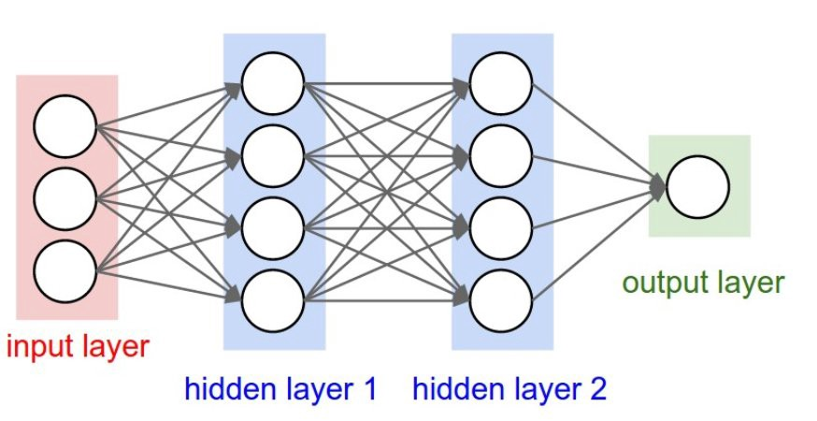

**Figure 1 – Layers in Neural Network**

In this paper we are going to use YOLOv5 R-CNN(Region based Convolutional Neural Network) for detecting and identifying the animals.

YOLOv5 architecture –

The YOLOv5 comprises of three important parts (refer to fig 2) :

1. Model Backbone– It is used to extract important features from the frame of video or image. In order to extract rich informative features from input, YOLOv5 uses the CSP (Cross Stage Partial Networks).
2. Model Neck – The primary purpose of model neck is to produce feature pyramids. Pyramids of features enable models to scale objects successfully in general. Models that use feature pyramid perform well on unobserved data. PANet is used in YOLOv5 as neck to get feature pyramid.
3. Model Head – The final detecting is primarily carried out using the model head. It applies anchir boxes to the features and produces final output vectors that includes bounding boxes, class probability and object scores.

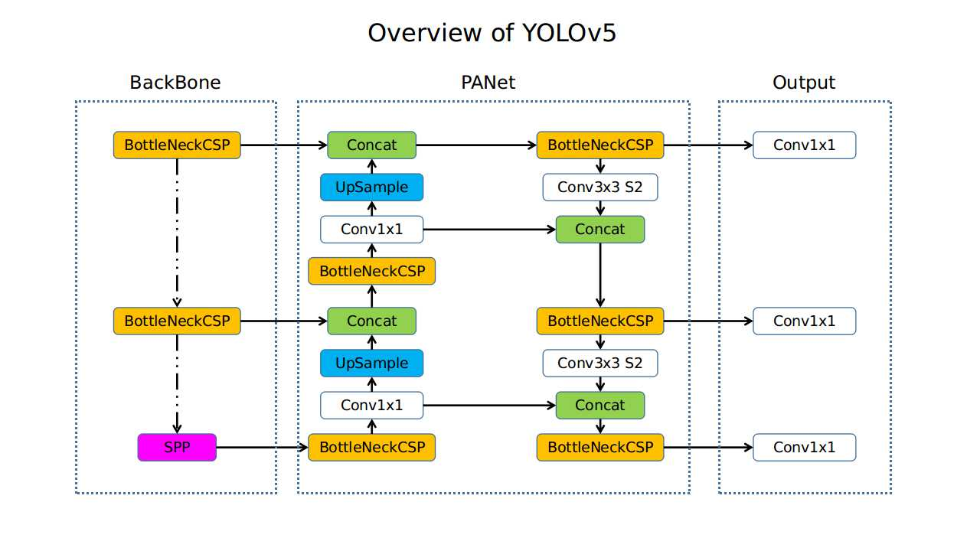

**Figure 2 – Architecture of YOLOv5**

Activation function used in YOLOv5 –

Following are the activation functions used in YOLOv5 :

1. Leaky ReLu –It is an activation function based on ReLu which consists of a small slope for negative values, refer to fig 3.Leaky ReLu is used in hidden layers in YOLOv5. Equation of leaky ReLu is

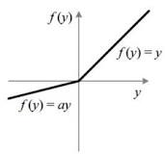

**Figure 3 – Leaky ReLu**

1. Sigmoid - It is an exponent based activation function which is simple. It provides output values in the range of 0 to 1, refer to fig 4. Sigmoid function suffers from gradient vanishing problem. Sigmoid function is used in the final detection layer. Equation of sigmoid is,

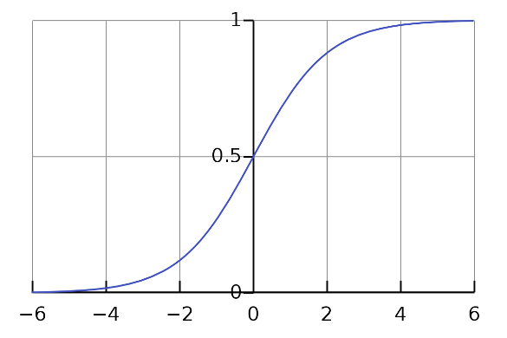

**Figure 4 – Sigmoid Activation Function Optimization**

Function Used In Yolov5 –

1. ADAM
2. SGD (STOCHASTIC GRADIENT DESCENT)

The Default Optimization F Nation For Training Is Sgd.

##### **Literature Survey**

[1] The paper talks about the conflict between humans and animals like monkey menace in urban areas and provides an effective solution by deploying intrusion detection applied with the help of wireless sensor based network based on UWB technology. The paper informs about SVM or softmax classifier to classify humans from animals. The intrusion of animals will be found by analyzing the UWB signals of the objects that entered the network , and extracting the features using convolutional neural network. The method proposed by the paper can allow us to detect human and animal invasion effectively with improved accuracy of 16% with respect to traditional manual extraction.

[2] The paper tries to tackle the problem of collision of animals and vehicles on roads which result in ecological imbalance. This paper tries to use animal detection via cameras that are installed on the roadside. The methodology used allows us to classify areas of image into two parts: animal and non-animal. In this paper, KNN and RF were used to process the features and it was found that KNN learning model was more reliable than Random Forest. For future, the paper suggested the use of deep learning to check for best possible methods in several conditions.

[3] The paper stated about the problem regarding the causalities and wounds caused due to road accidents due to collision with animals on mainly highways. The paper tries to implement a low cost animal detection using computer vision. The algorithm used for detection is based on HOG and cascade classifier. Training is done on more than 2000 images which contains positive and negative images. The system was ale to achieve max accuracy of 82.5% for detection. The limitation regarding the system is that it can detect and prevent collision till the range of 30-35km/h after which the system can detect but cant prevent the collision.

[4] The paper gives a sequence of algorithm components for the first stage of animal recognition pipeline called detection. The paper informs about 5-component detection pipeline ,each of which is a separate deep convolutional neural network, that can be used in computer vision based animal recognition system. The paper introduced a new dataset named WILD that can be used to challenge detection scenarios. The method used by the paper was able to poll off a localization mAPof 81.67% along with species and viewpoint annotation classification efficiency of 94.28% and 87.11% respectively along with an AoI accuracy of 72.75% across 6 defined animal species. For future the paper suggested improvements on WILD and performing comprehensive identification performance.

[5] The paper tries to tackle the problem of counting livestock like sheep on a regular basis which is otherwise done on major events like shearing or loading. The paper focuses on detecting sheep in padlock through UAV video and count sheep. The paper used 2 methods (i) a Region based Convolutional Neural Network for the detection of sheeps and (ii)an Expert System which took the advantage of uniform white color of sheep and blob analysis was done on the greyscale image. Both methods performed well but the method involving R-CNN require more work.

[6] The paper talks about the problem of human animal conflict which results in enormous amount of resource loss like loss of crops, livestock, property etc. To tackle the stated problem, the paper states a animal monitoring system that monitors a zone to prevent the entry of wild animals. The monitoring system consists of sensor that detects any intrusion and then camera is used to find the image of intruder and the image is classified using image classifier and suitable action is taken based on the class of intruder and a notifies owner using GSM.

[7] The paper proposes a wildlife monitoring and analysis system using deep convolutional neural network. The methodology consists of pre-processing, fine tuning DCNN features and classification through learning algorithms. The classification is done through transfer learning for which VGG-F pretrained model is used. The model used was pre-trained on ILSVRC 2012 dataset. For animal-background verification model training, classification uses machine learning algorithms such as SVMs, KNNs and ensemble algorithms. The end result showed that the accuracy of animal detection was 91% with F1-measure having max value 0.95. An accuracy of 91.4% with weighted KNN and DCNN features was obtained. The proposed system in the paper is able to detect wild animal during both day and night time.

[8] The paper deals with wild animal surveys and proposed a deep learning system to aid UAS (Unmanned Aircraft Systems) in detection of animals. Mainly two neural networks were used namely RetinaNet, a deep CNN that helped in achieving high precision and accurate animal surveys in UAS algorithms, and You Only Look Once v3 (YOLOv3), a single pass deep CNN that was able to develop a reliable model for automated counting of wild animals in UAS imagery. For future, the deep learning model can be made to support multiclass object system.

[9] The paper proposes the use of drones for cattle detection. The images that were captured by drone are analyzedby CNN to identify the object captured in the image. The CNN was trained to detect cattle The architecture used for cattle detection is 64x64-18C7-MP4-96C5-MP2-4800L-2.The dataset was created from recordings made by a multirotor at different heights.The training dataset consist of samples of target, i.e. cattle, and the background. The average accuracy obtained in training was 97.1% and during testing an accuracy of 95.5% was obtained. For the future work, the CNN can be further trained to count the animals that have been grouped in the cattle.

[10] The paper suggests a machine learning pipeline for underwater animal detection system that allows us to monitor and understand the marine ecosystem. The dataset used was created using satellite images near LoVe observatory as it is rich in biodiversity. For the classification 2 versions of SVM and 4 CNN were used. The first SVM was linear and had C=1 and the second SVM was also linear but it had stochastic gradient descent training. For the CNN, two different structures were used. The first structure (CNN-1 and CNN-3) consisted of 2 blocks of convolution, activation and pooling layer while second (CNN-2 and CNN-4) contained 3 blocks. The first SVM had an accuracy of 0.5137 while the second had 0.4196 and CNN-1 had an accuracy of 0.6191, CNN-2 had an accuracy of 0.6563, CNN-3 had an accuracy of 0.6346 and CNN-4 had an accuracy of 0.6421. Using the various techniques an accuracy of 76.18% and AUC of 87.59% was achieved.

1. **METHODOLOGY**

This project uses public dataset for automated animal detection and identification called Simple wildlife animals created by Radulh ( <https://www.kaggle.com/datasets/radulh/simple-wildlife-animals> ). The dataset consists of 6 classes of animals consisting 180 images out of which we have selected only 3 classes for experimentation of our algorithm. These classes are shown in table 1

**Table 1. Dataset Specifications**

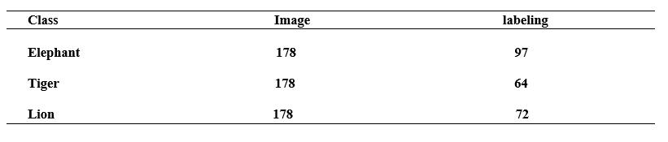

Some samples from the dataset are shown in Fig. 1

1. 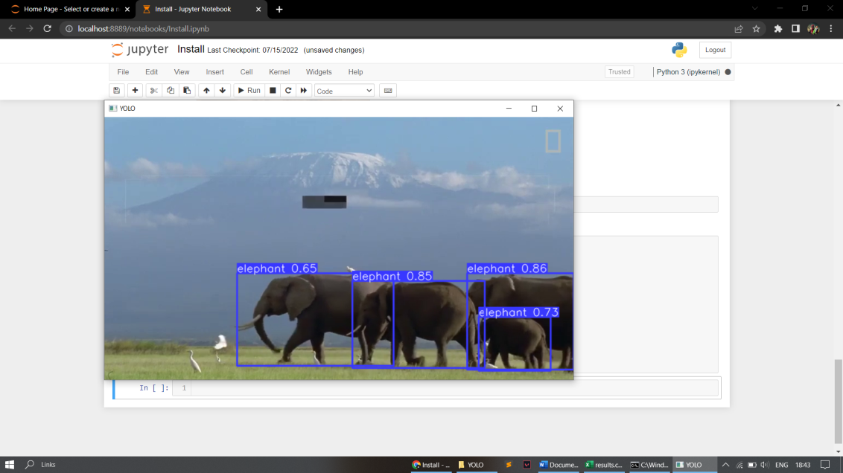
2. 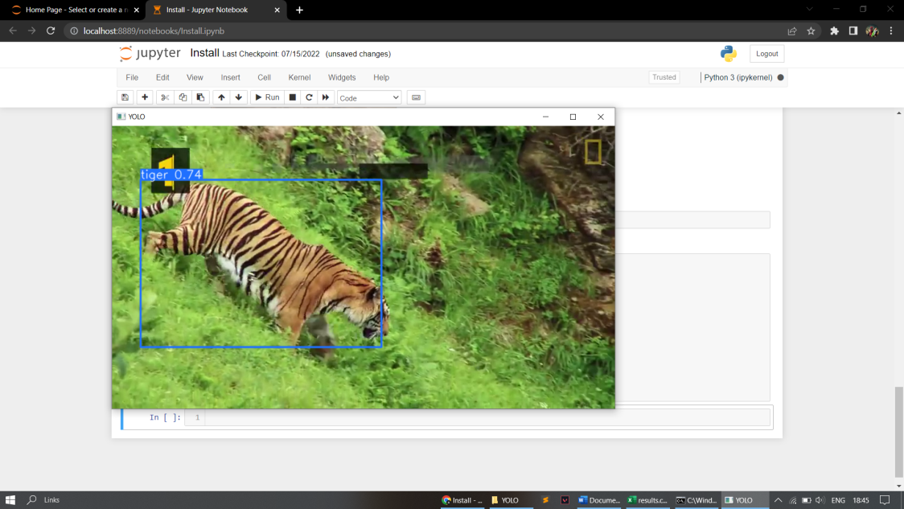
3. 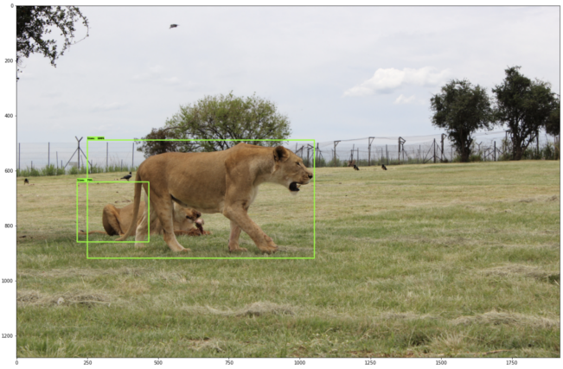

**Dataflow Chart -**

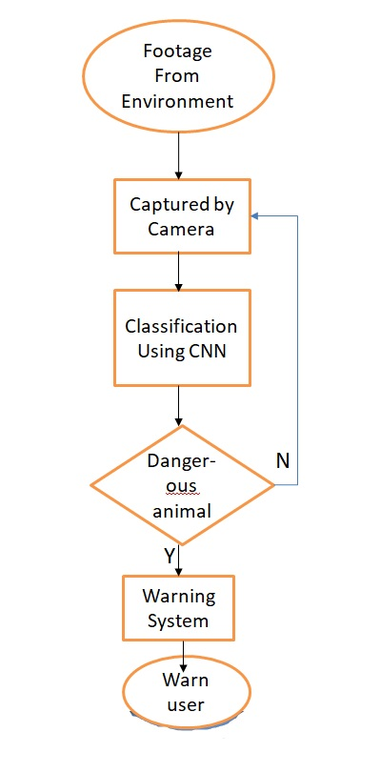

##### **RESULT**

After training the YOLOv5 model on 3 different animal classes namely lion, tiger and elephant we were able to attain a max value of 0.98 in the f1 curve(refer to fig 1), max value of PR curve as 0.993mAP @0.5(refer to fig 2).

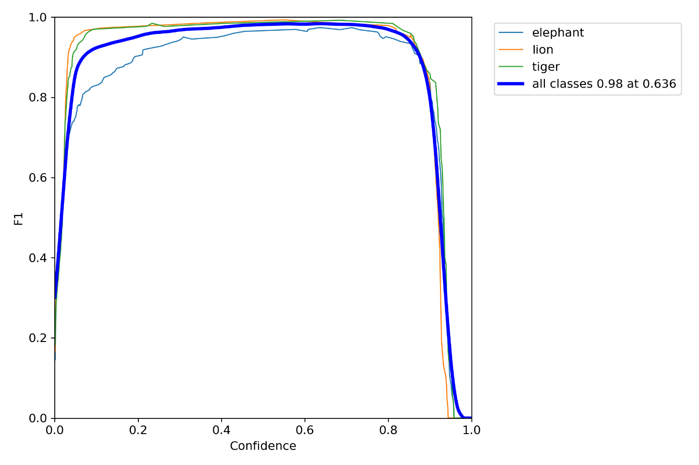

**Figure 1– F1 vs confidence graph**

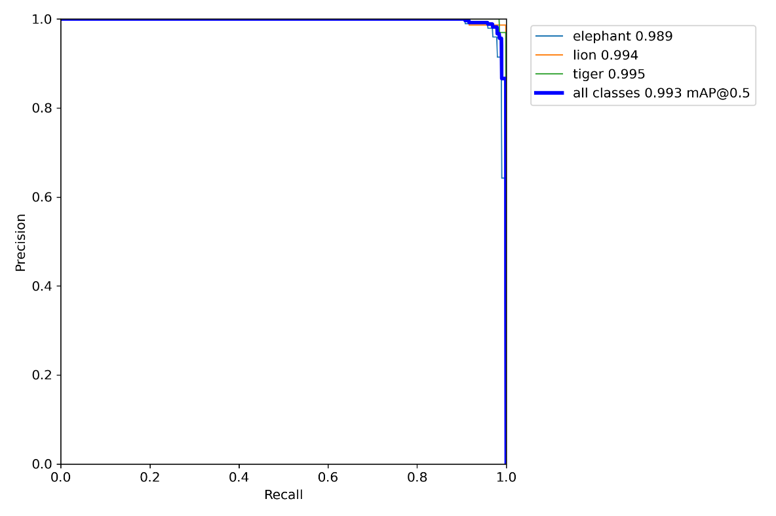

**Figure 2 – PR curve**

Confusion matrix of the trained model is shown in figure 3.

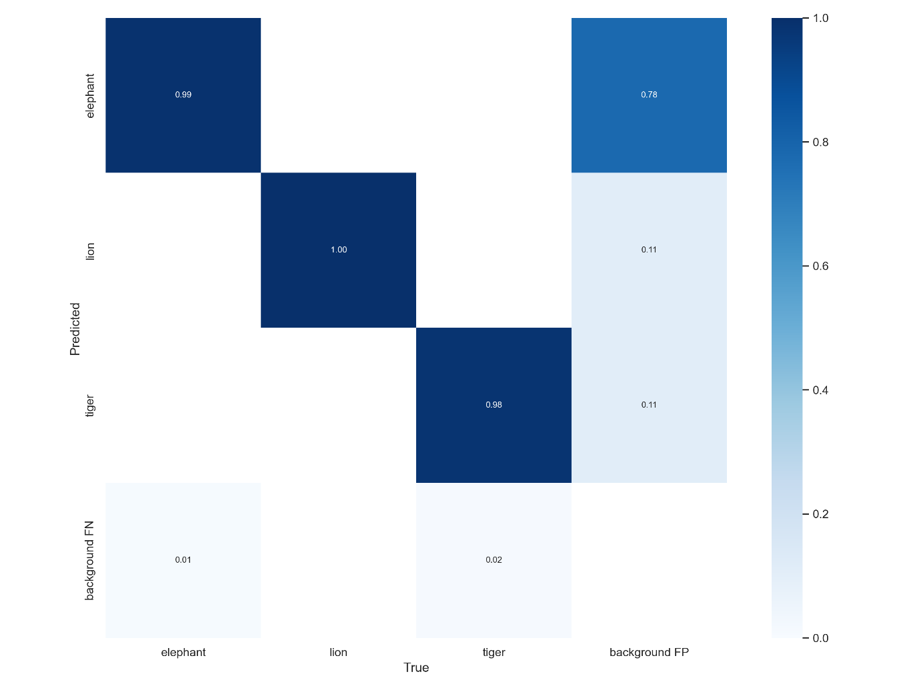

**Figure 3 – Confusion Matrix**

The YOLOv5 model was able to achieve an accuracy of 98% during training whose results are shown in figure 4

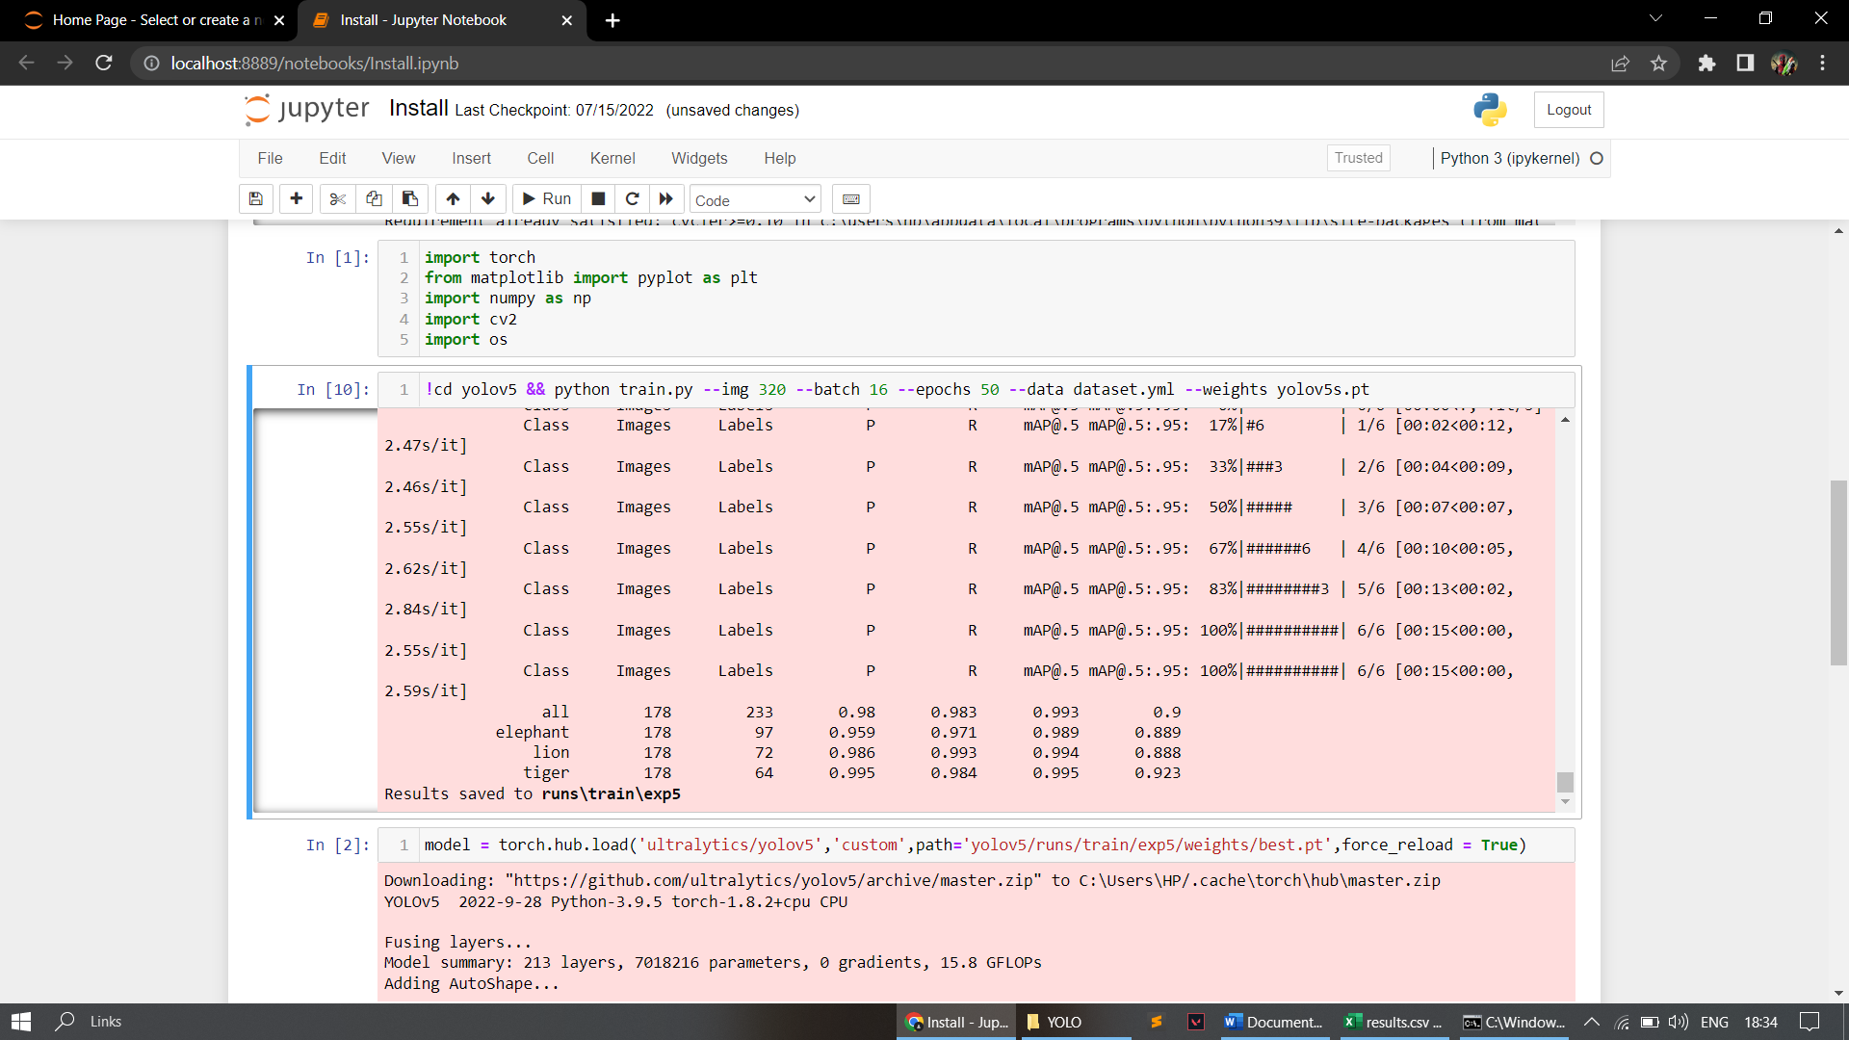

**Figure 4 – Output of training**

A max accuracy of 86.4% was obtained during the testing of YOLOv5 model on video input. Results of testing are shown in fig 5 and 6.

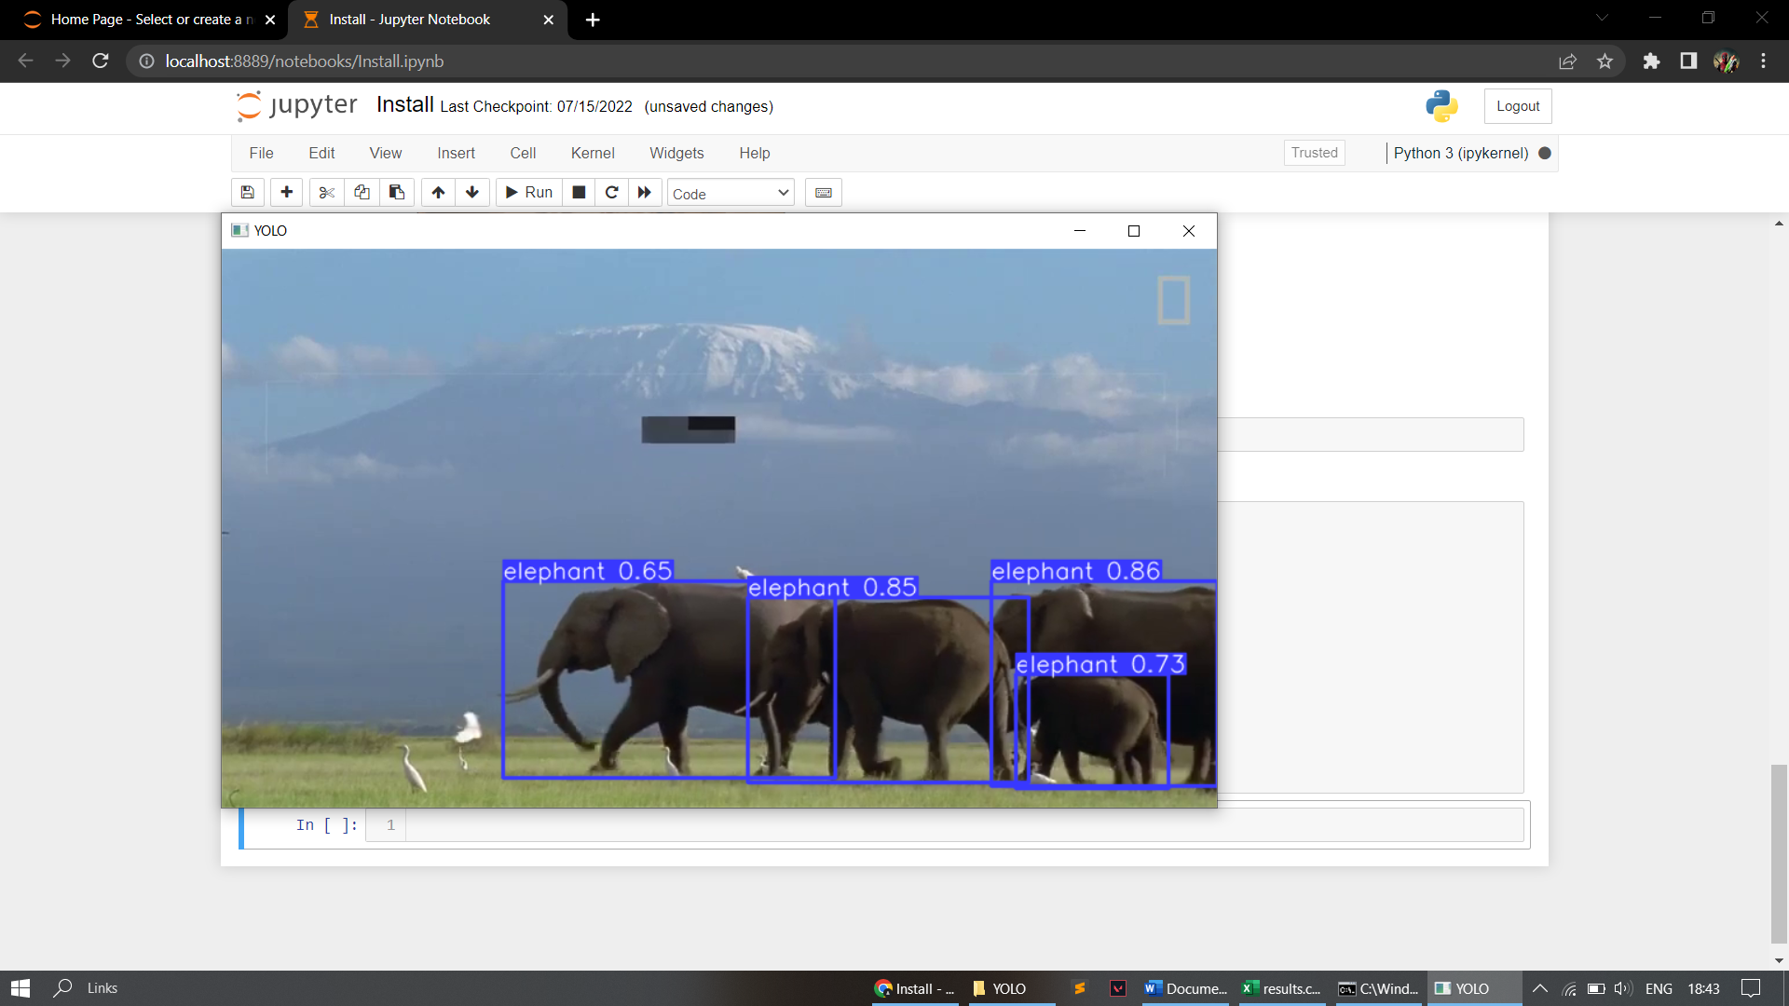

**Figure 5 – Testing the model through input video**

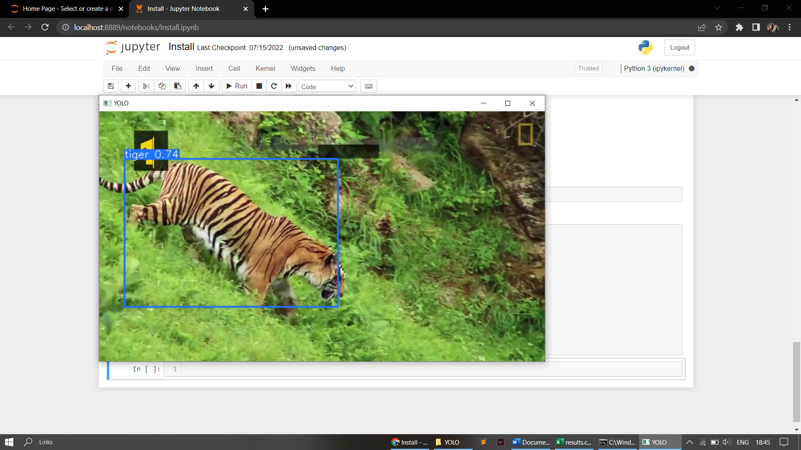

**Figure 6 – Testing the model**

**Through input video**

###### CONCLUSION

In this paper, we use R-CNN to provide a trustworthy and reliable method of detecting animals in cluttered photos and videos. We were able to train the R-CNN model and achieve a max accuracy of 86.4% which can be used in various applications of animal detection. For future work, we can try to optimize the model by adjusting the layers and we can also try to implement the same model in some application of animal detection like cattle counting etc.

##### **REFERENCES**

1. Animal Intrusion Detection Based on Convolutional Neural Network byWenlingXue*, Ting Jiang*, Key Laboratory of Universal Wireless Communication Beijing University of Posts and Telecommunications Beijing, China,Ting Jiang* School of Electronic and Computer Engineering, ZhijiangWanliUniversity,Ningbo, China.
2. A Proposal of an Animal Detection System Using Machine Learning by William H. S. Antônio, Matheus Da Silva, Rodrigo S. Miani& Jefferson R. Souza
3. A Practical Animal Detection and Collision Avoidance System Using Computer Vision Technique by SACHIN UMESH SHARMA1 AND DHARMESH J. SHAH2. 1 - Department of Electronics and Communication, Gujarat Technological University, Ahmedabad 382424, India. 2 - Department of Electronics and Communication, Sankalchand Patel University, Visnagar 384315, India.
4. An Animal Detection Pipeline for Identification by Jason ParhamCharles Stewart - Rensselaer Polytechnic Institute , Jonathan Crall - Kitware, Inc., Daniel Rubenstein - Princeton University, Jason Holmberg - Wild Me , Tanya Berger-Wolf University of Illinois-Chicago.
5. Detecting and Counting Sheep with a Convolutional Neural Network by Farah Sarwar1,2, Anthony Griffin1,2 ,Priyadharsini Periasamy2 , Kurt Portas3 and Jim Law3, 1 High Performance Computing Research Lab, 2 Electrical and Electronic Engineering Department School of Engineering, Computer and Mathematical Sciences Auckland University of Technology, New Zealand, 3 Palliser Ridge Limited, Pirinoa, New Zealand.
6. IoT – based Wild Animal Intrusion Detection System by Prajna P, Soujanya B.S – Information Science Engineering, Vivekananda Collge of Engineering and Technology, Puttur.
7. Wild Animal Detection Using Deep Convolutional Neural Network by Gyanendra K. Verma and Pragya Gupta
8. Wild animal survey using UAS imagery and deep learning: modified Faster R-CNN for kiang detection in Tibetan Plateau byJinbang Peng, Dongliang Wang,Xiaohan Liao, Quanqin Shao,Zhigang Sun,Huanyin Yue,Huping Ye.
9. Detection of Cattle Using Drones and Convolutional Neural Networks by Alberto Rivas, Pablo Chamoso, Alfonso González-Briones and Juan Manuel Corchado.
10. Video Image Enhancement and Machine Learning Pipeline for Underwater Animal Detection and Classification at Cabled Observatories by Vanesa Lopez-Vazquez, Jose Manuel Lopez-Guede, Simone Marini, Emanuela Fanelli, Espen Johnsen and Jacopo Aguzzi.